Victoria State User Manuel

Table of Contents
Introduction 3
Getting Started 3
Step-by-Step Guide 11
Home Page 11
Selected Period Accidents 11
Hourly Accidents 14
Keyword Accidents 17
Impact of Alcohol 20
Speed Related Incidents 23
Trouble Shooting 25
FAQ 26
Contact us 26

Introduction

Welcome to Victoria State Accident Dataset. This is an interactive app to help with the providing the public with a interactive way of seeing the past accidents cause by different obstacles over the past few years. This app is for educational purposes to help cause awareness of the possible outcomes of accidents within the state of Victoria. This app will allow:
- For a user-selected period, display the information of all accidents that happened in the period.
- For a user-selected period, produce a chart to show the number of accidents in each hour of the day (on average).
- For a user-selected period, retrieve all accidents caused by an accident type that contains a keyword (user entered), e.g. collision, pedestrian.
- Allow the user to analyse the impact of alcohol in accidents – ie: trends over time, accident types involving alcohol, etc.
- Allow the user to analyse the impact speed in accidents – i.e: different speed to severity of the accident

Getting Started

To get started please download “anaconda” on your PC or Macbook via this link https://www.anaconda.com/download. Once downloaded follow the steps and install it onto your laptop.
After that I’d recommend using PyCharm Community which you can download via here https://pycharm-community-edition.en.download.it

Once both are installed, open Anaconda and select the environments tab on the left.
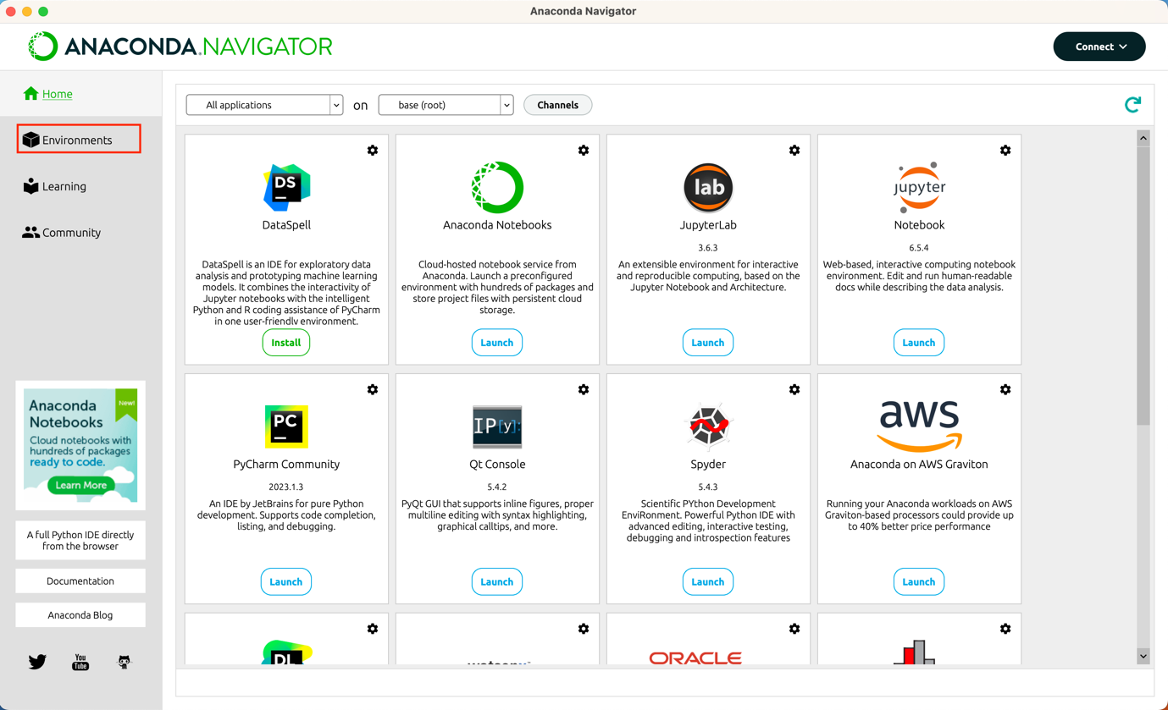

Next create a new environment and give it a name.
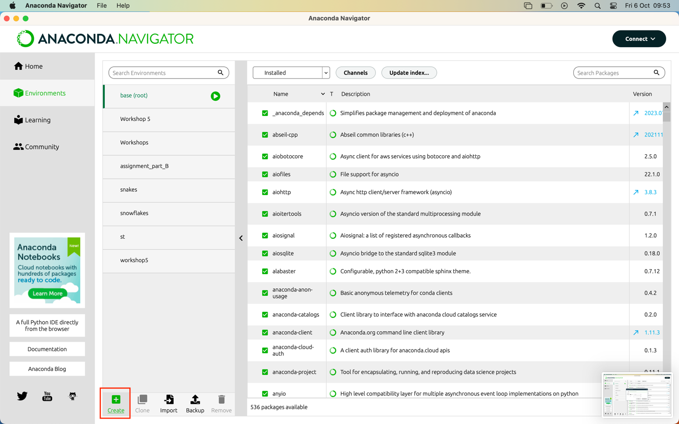

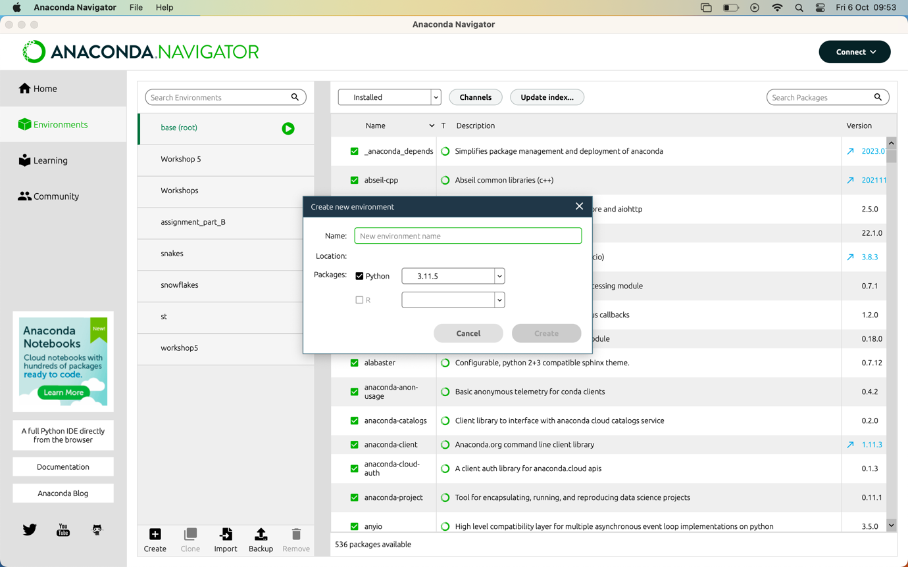

Next install wxpython. This can be done in two ways.

Firstly, if on a MacBook open the terminal app and type in “conda env list”.

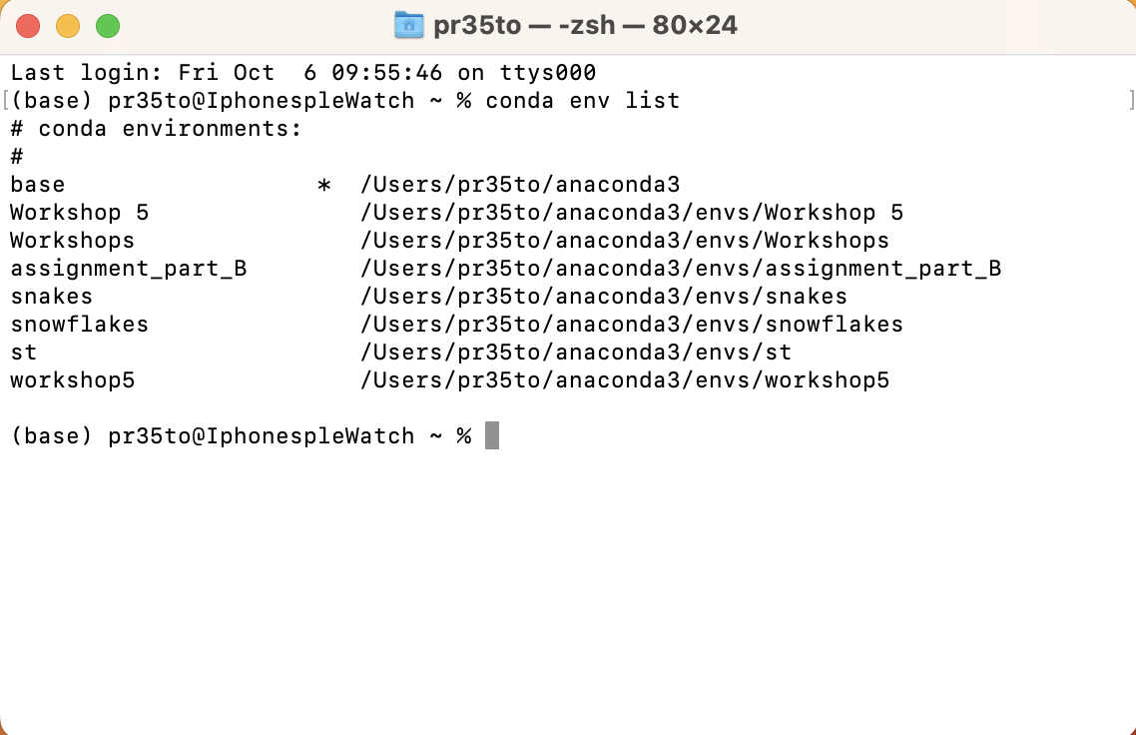

This will now show all the environments you have created (including the base environment).
Next activate the environment you want to you by typing in “conda activate [name of environment]
In this case I will activate my “st” environment.
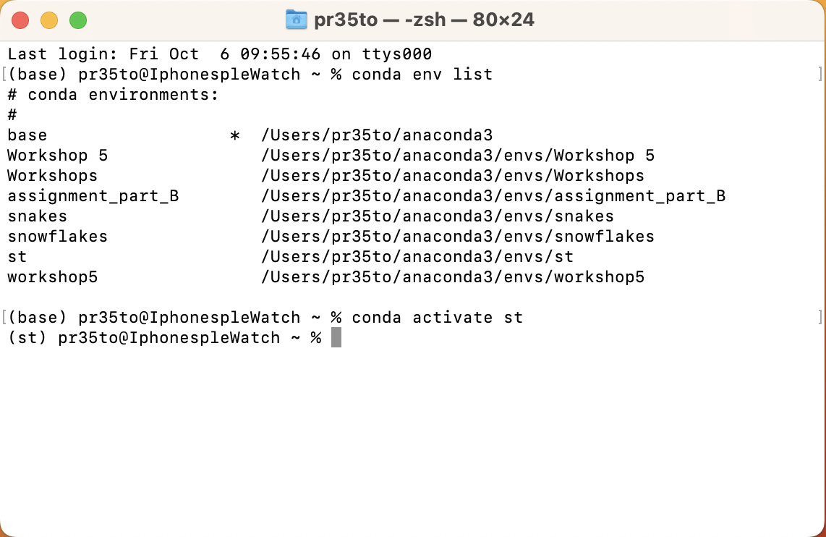

Now type in the line “conda install wxpython -c conda-forge”

The second way is to do it through the the anaconda app.

First select the environment in which you want to use in this case I will use the “assignment_part_B” environment

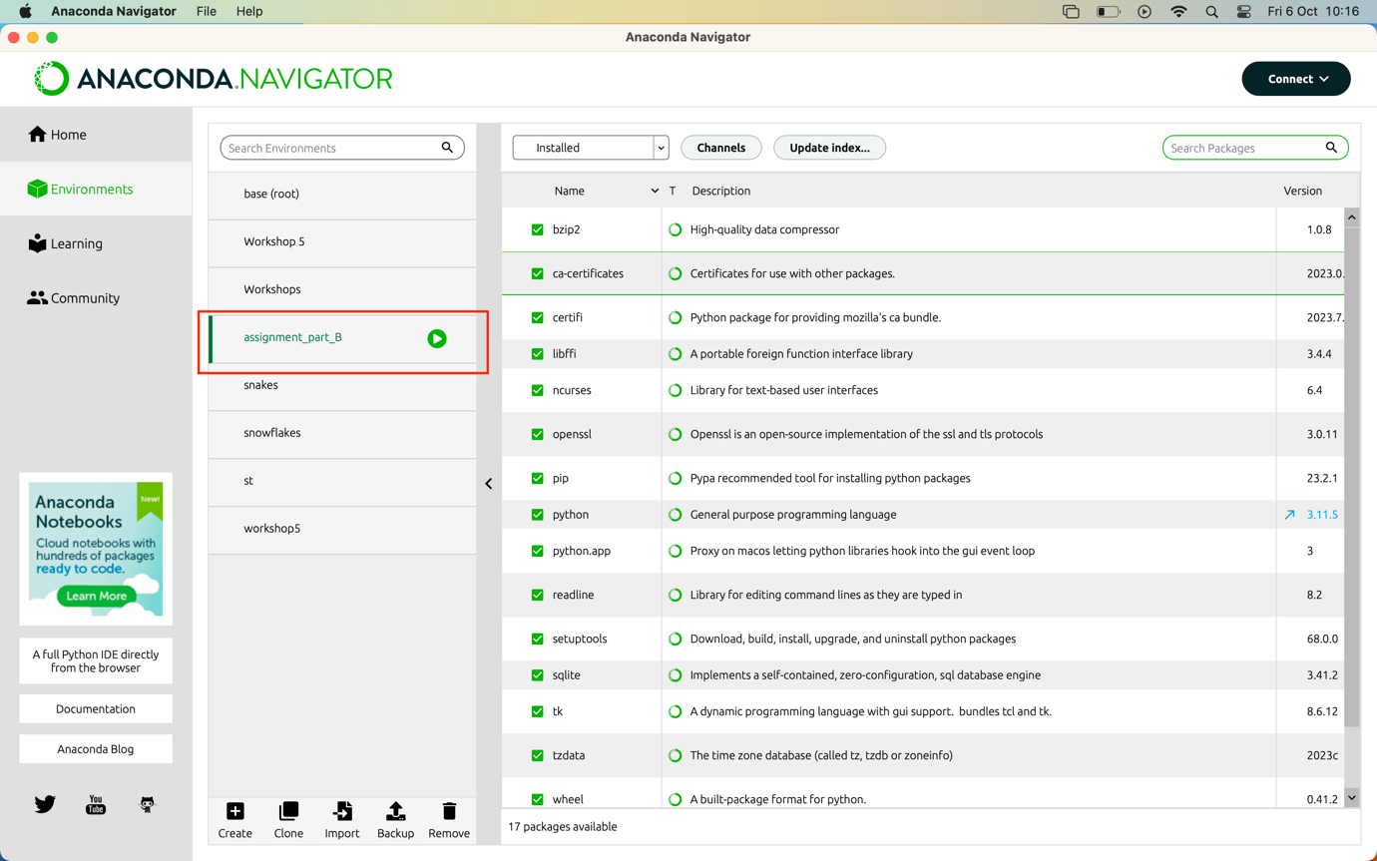
Now select “not installed” from the drop down menu

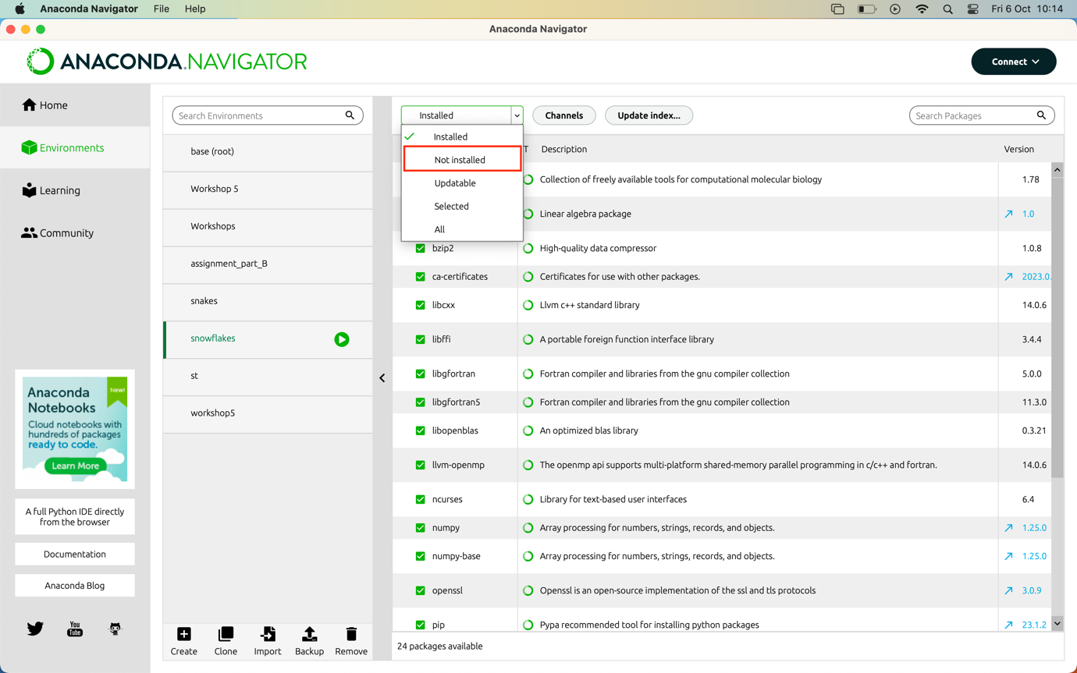

Now search for “wxpython” in the top right corner

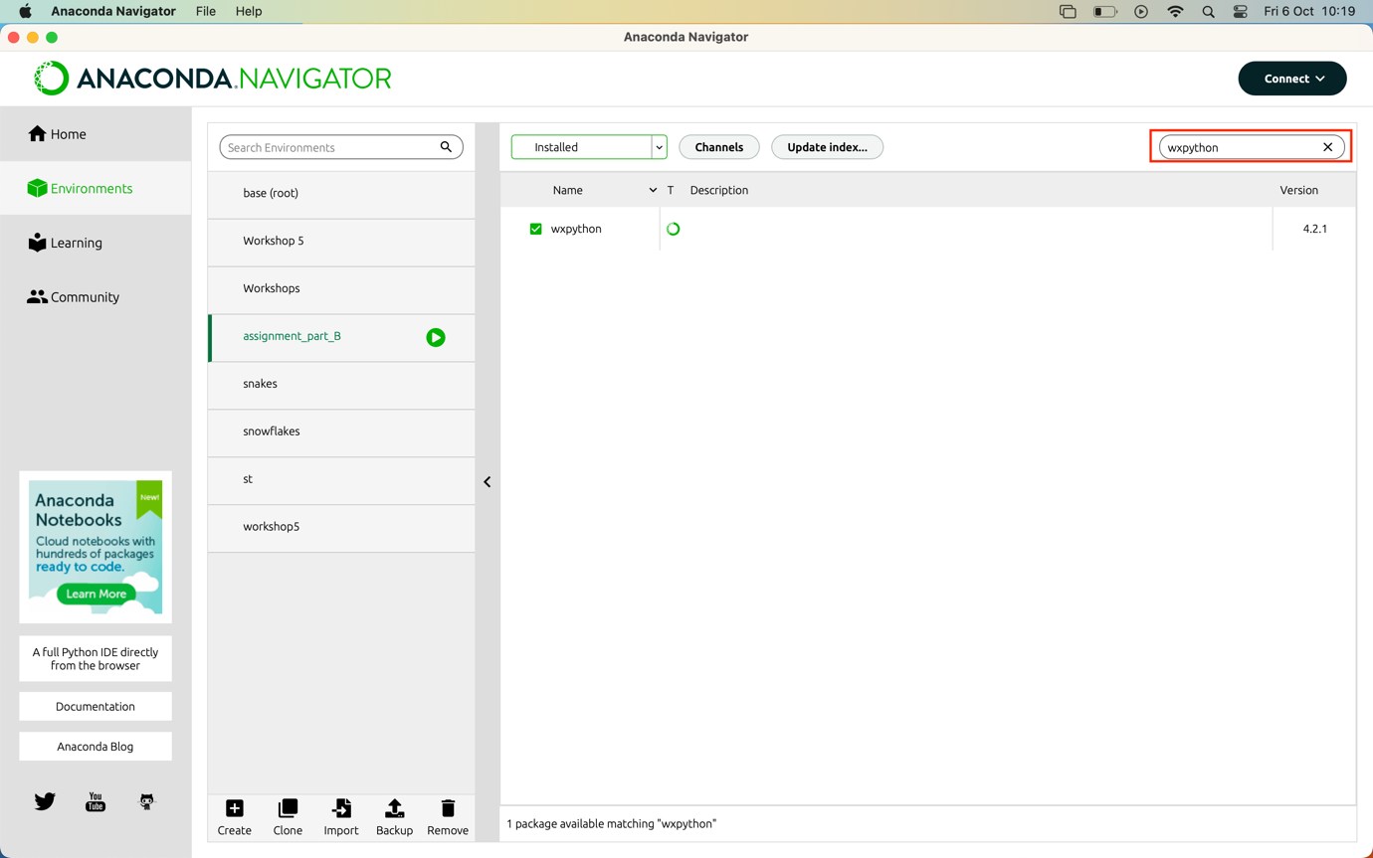

In my case it is already installed but for you tick the box next to “wxpython” and select “apply” in the bottom right hand corner and wxpython will be installed.

Once all this is done open “Pycharm Community” and select “new project”

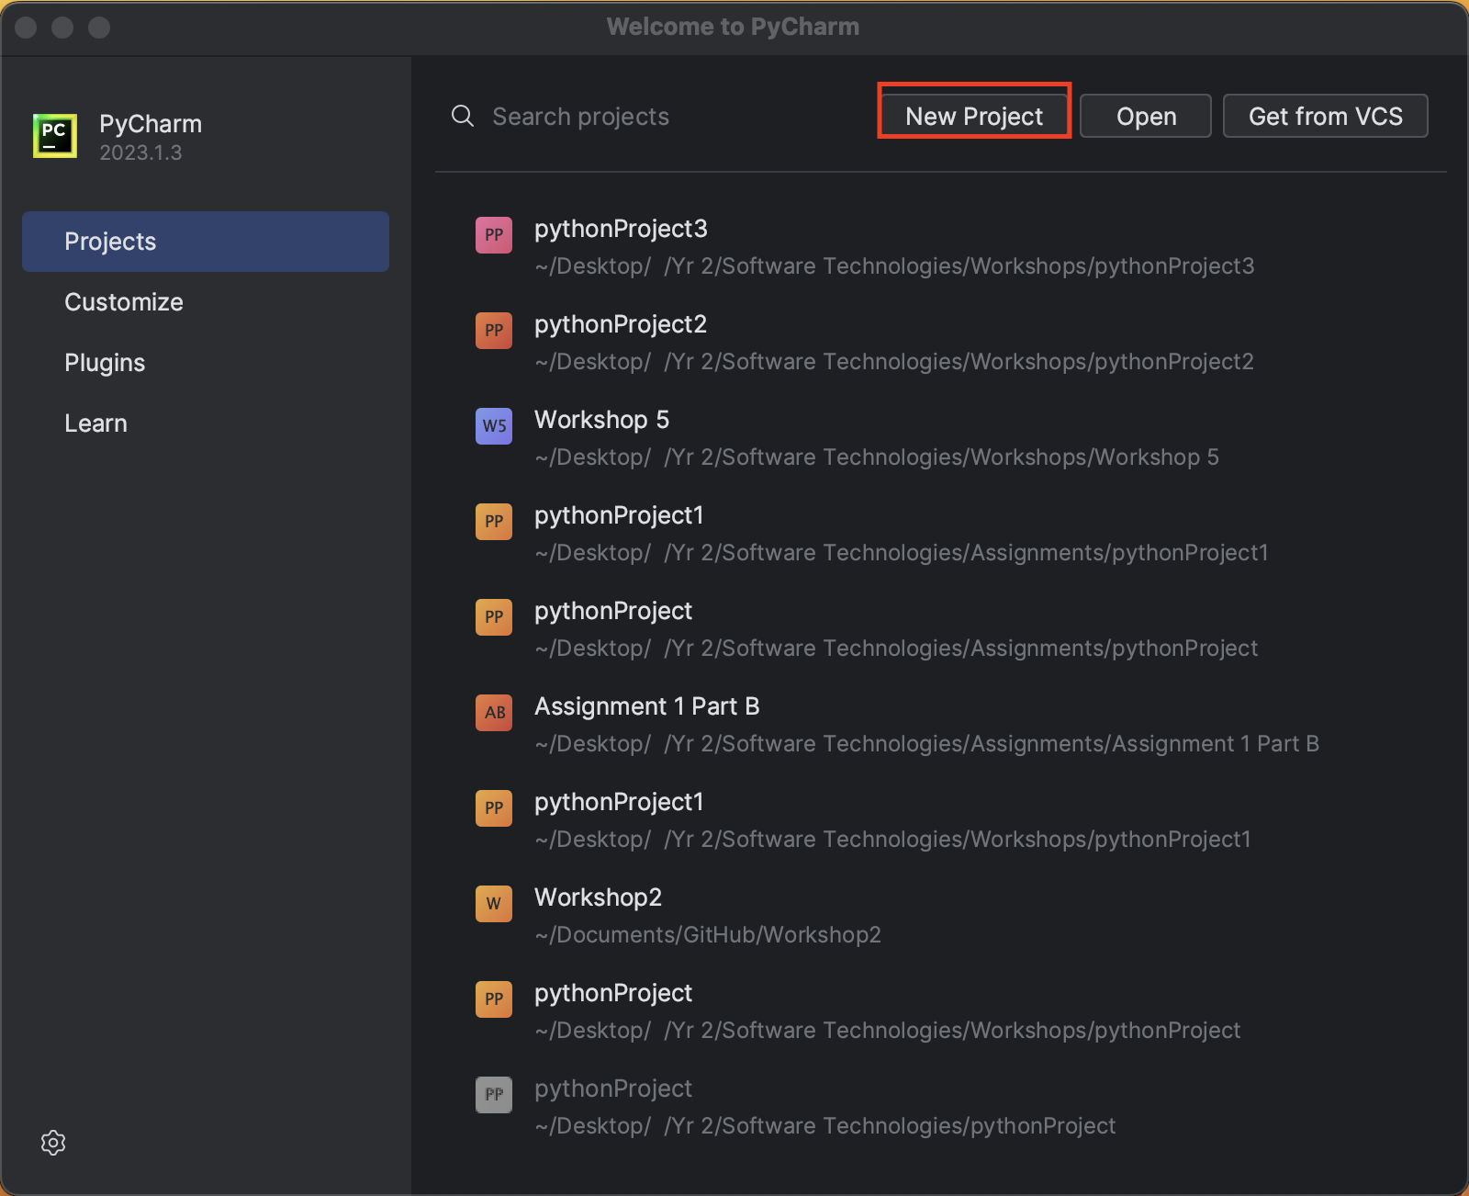

Next select “previously configured interpreter” and then “add interpreter”

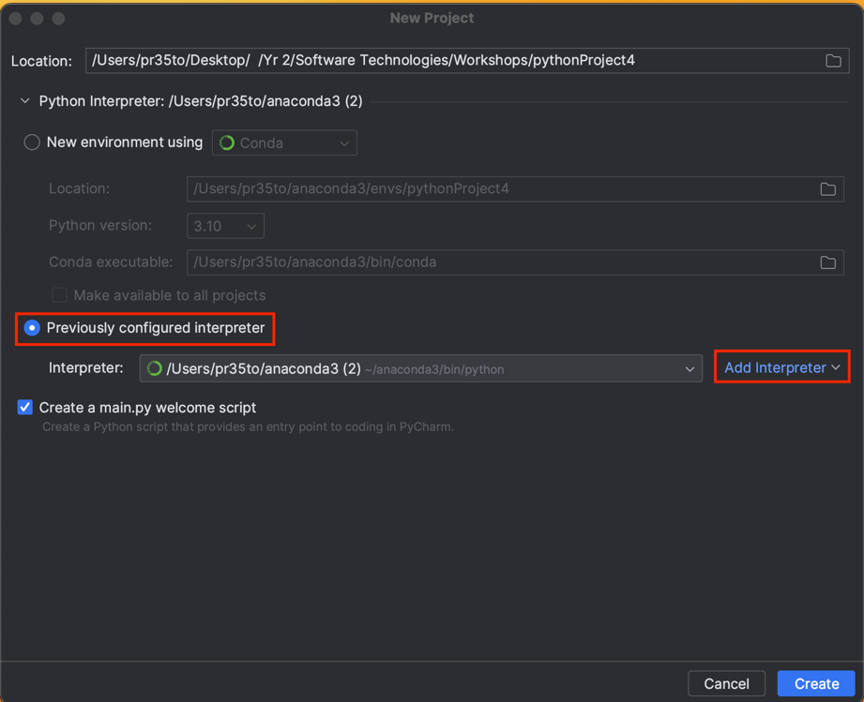
Now select “conda environment” on the left

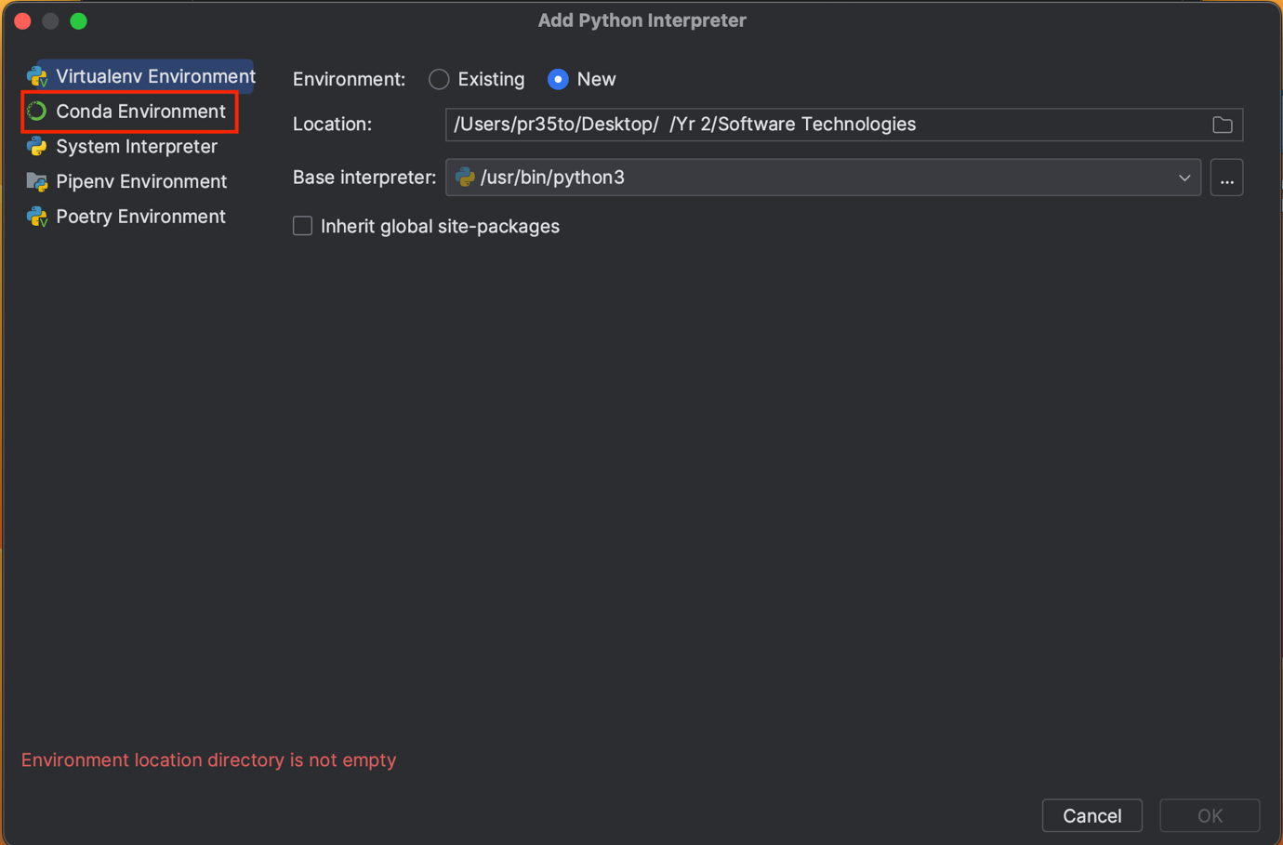

And now select your environment you just created from anaconda and save it

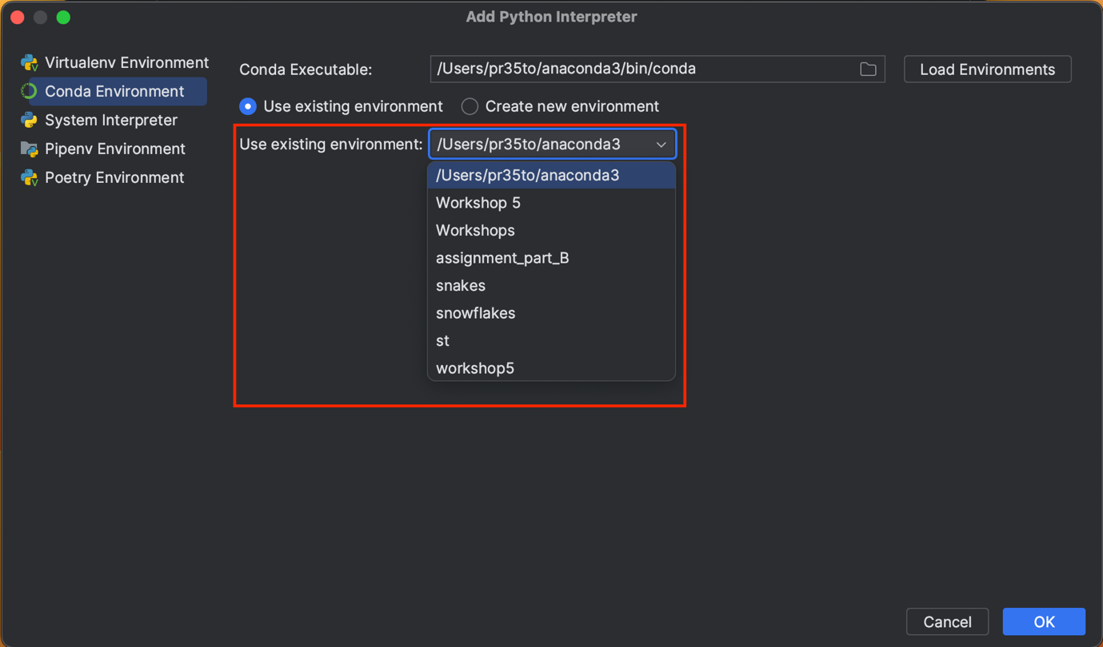

Now once you have your project created you need to do these last final steps.
  - Create a new file
  - In the new file open the terminal option either at the bottom of the screen or bottom left

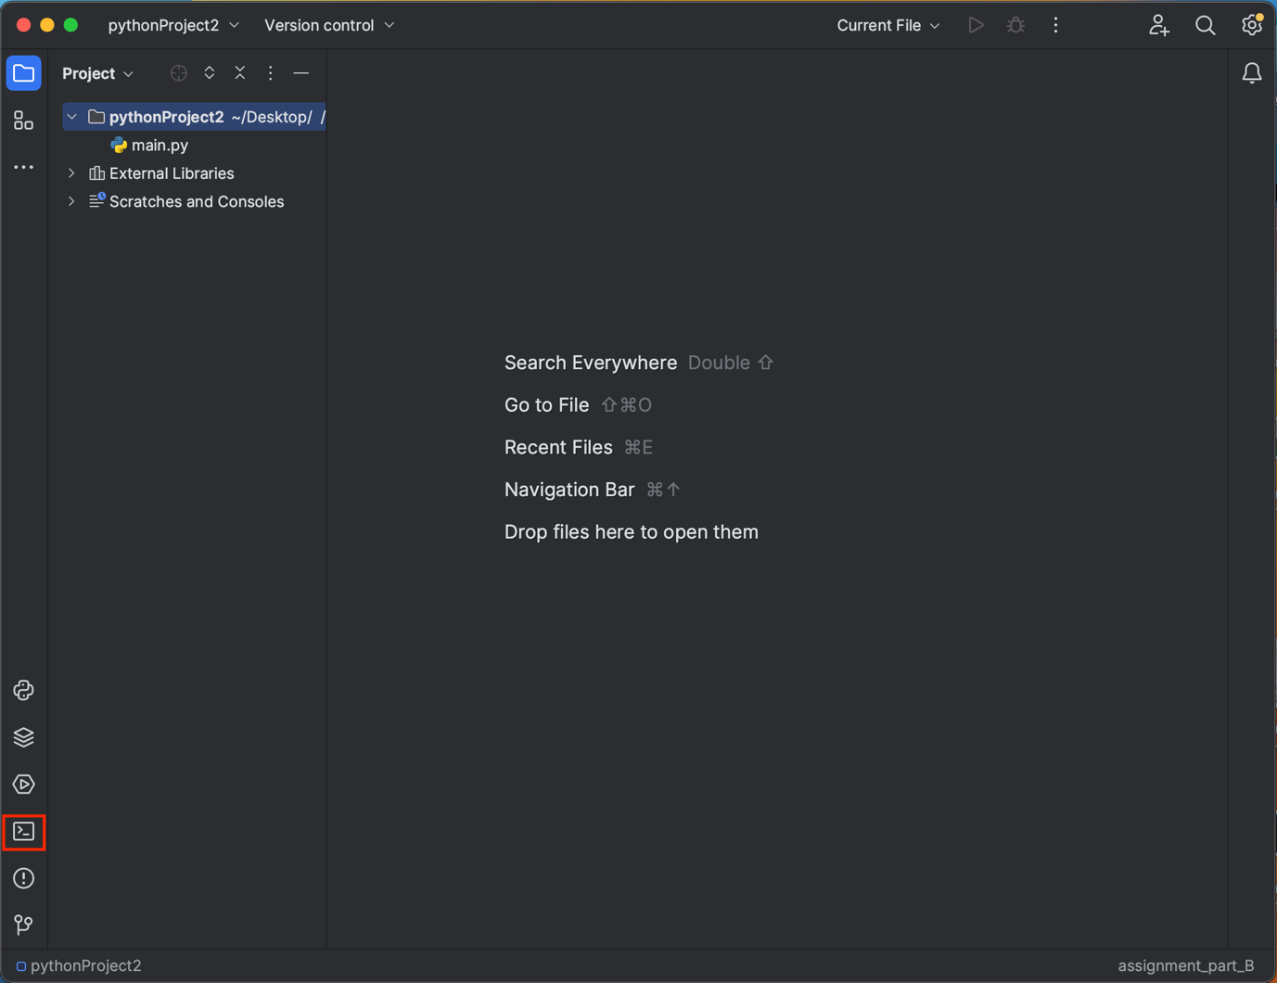

No type in these commands in the terminal window:

- Conda activate [environment name]
- Pip install wxpython
- Pip install matplotlib
- Pip intstall pandas

Now if you have a macbook youll need to install the wxformbuilder app and this can be done through this link and following the instructions for a macbook by copying and pasting the code provided into the terminal window: https://github.com/wxFormBuilder/wxFormBuilder

If you have a windows or a pc you can use this link https://github.com/wxFormBuilder/wxFormBuilder/releases and download the “wxFormBuilder-3.10.1-x64.exe” file

Step-by-Step Guide

Home Page

Once the app is up and running you’ll come across the home page (image below). As you can see highlighted at the top of the page is the task bar which you will use to switch between pages. This page is used to just give an understanding of what the app is about.

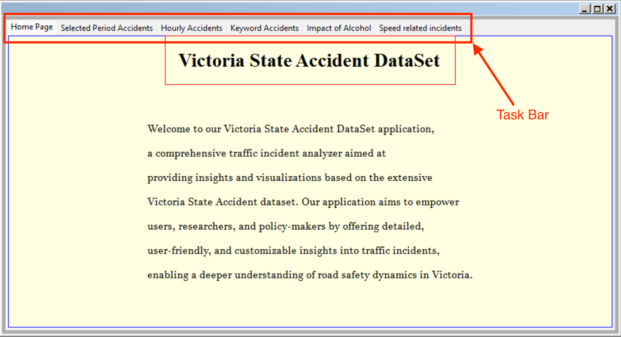

Next to switch to the second page hover you mouse over the task bar and click on the “Selected Period Accidents” page which will look like below.

Selected Period Accidents

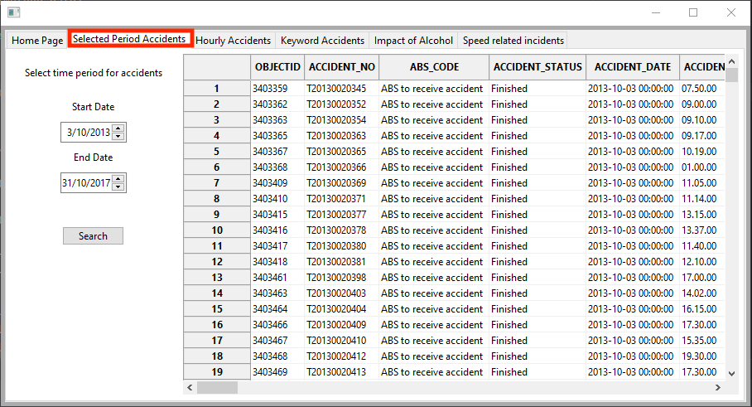

- First enter the first date

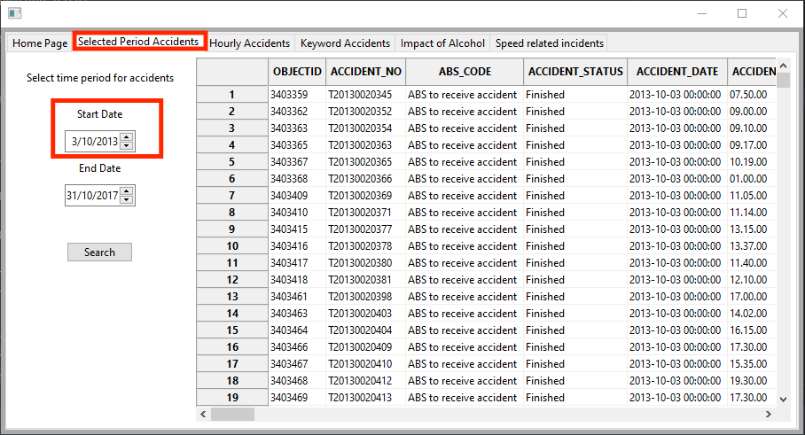

- Now enter the end date

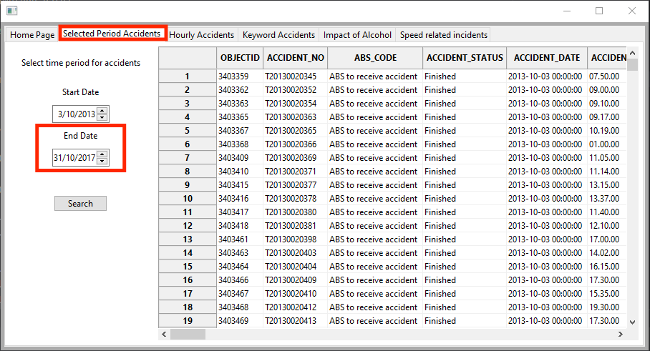

- Next to get the data click the “search button and the data will be displayed on the right like in the photo

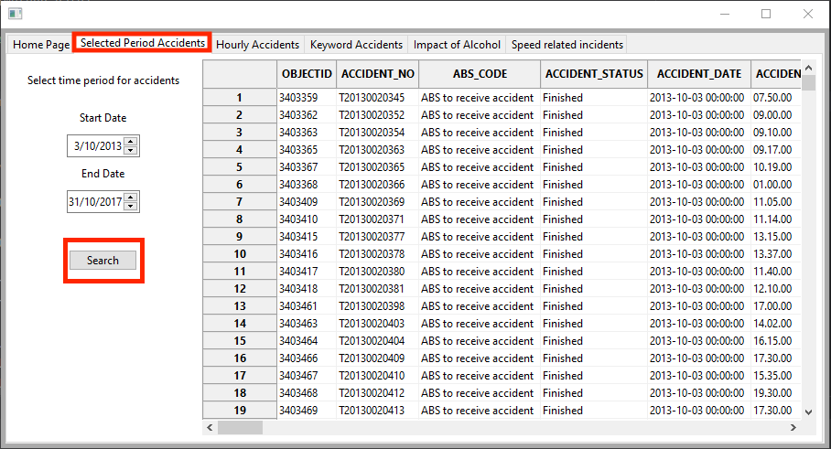

Now to switch pages click the “Hourly Accidents” tab in the task bar

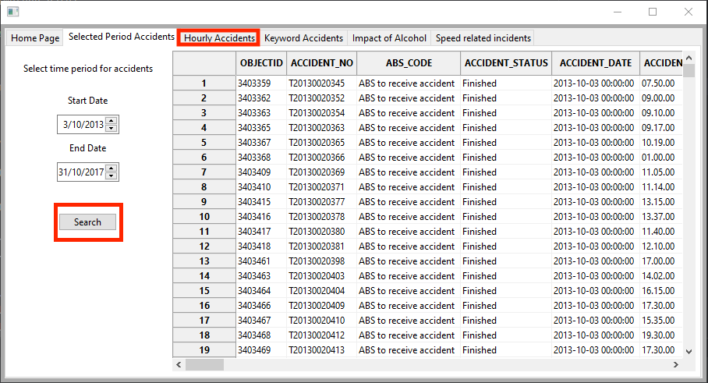

Hourly Accidents

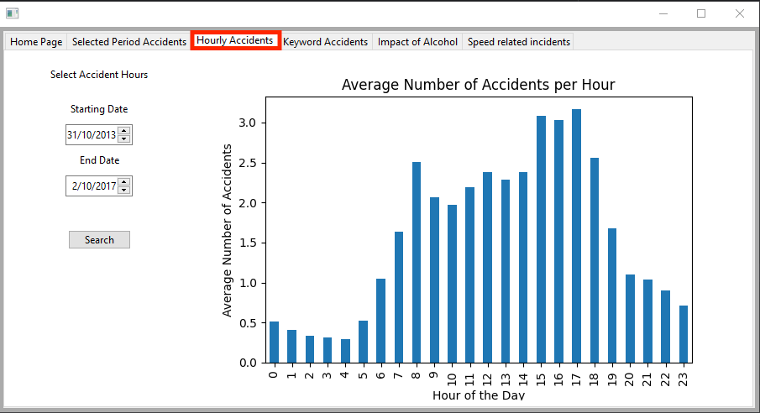

- First enter the start date
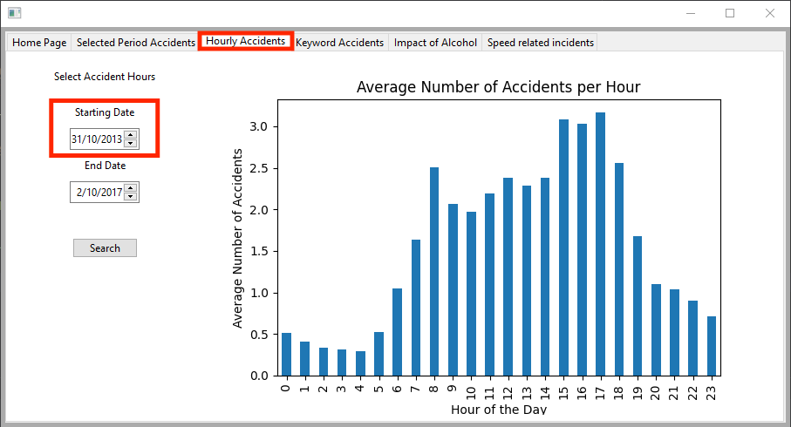

- Next enter the end date

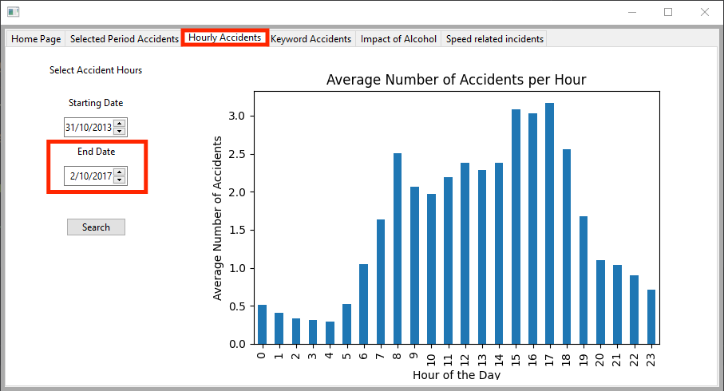

- Now click the search button to see the results

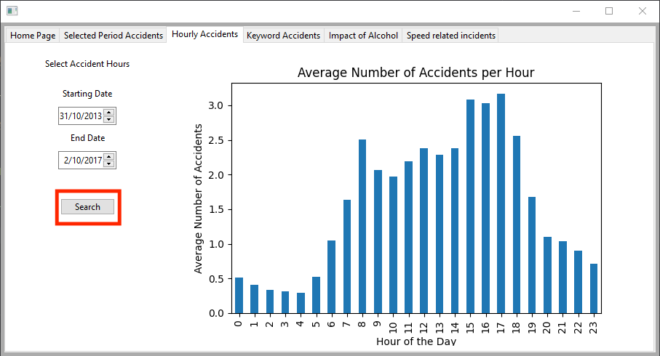

Next to switch pages click the “Keyword Accidents” page in the task bar

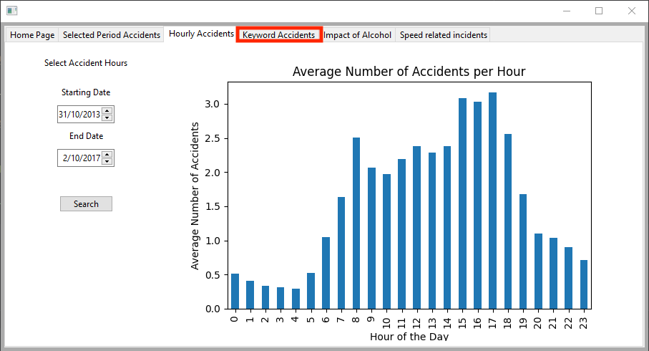

Keyword Accidents

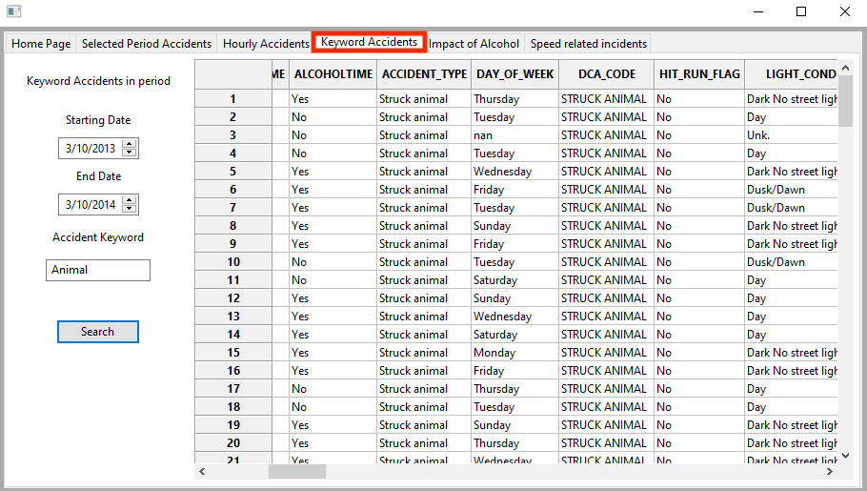

- Like every other page. First enter the start date

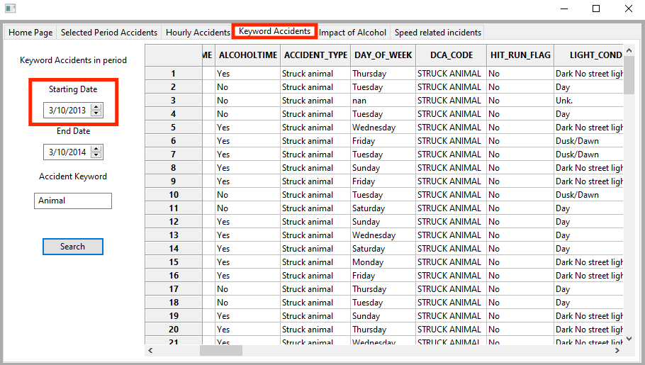

- Second enter the end date

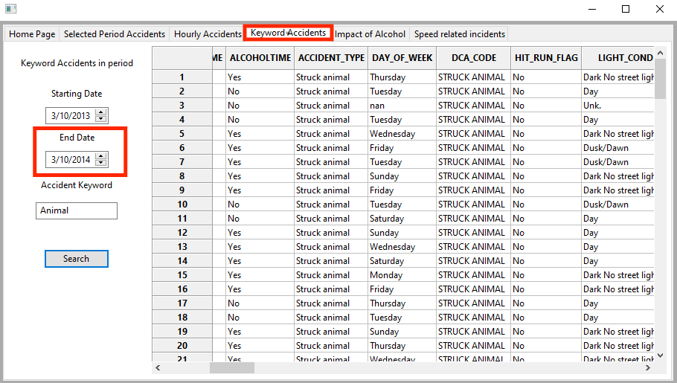

- Now you can search for a specific key word for what type of accidents you are looking for by typing in the work box
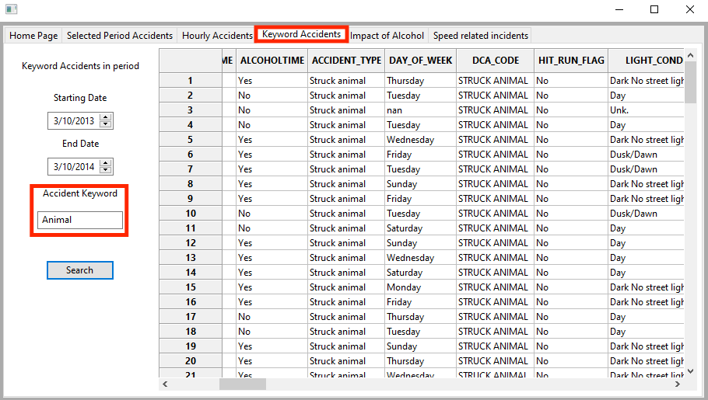

- Now click the search bar to see the results on the right
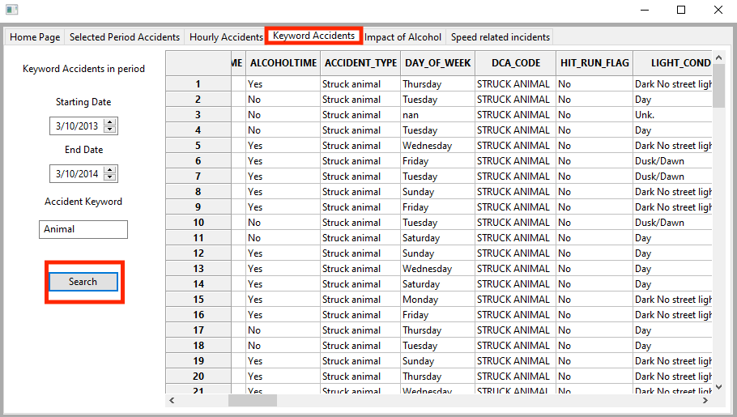

Now to switch pages click on the “Impact of Alcohol” page in the task bar

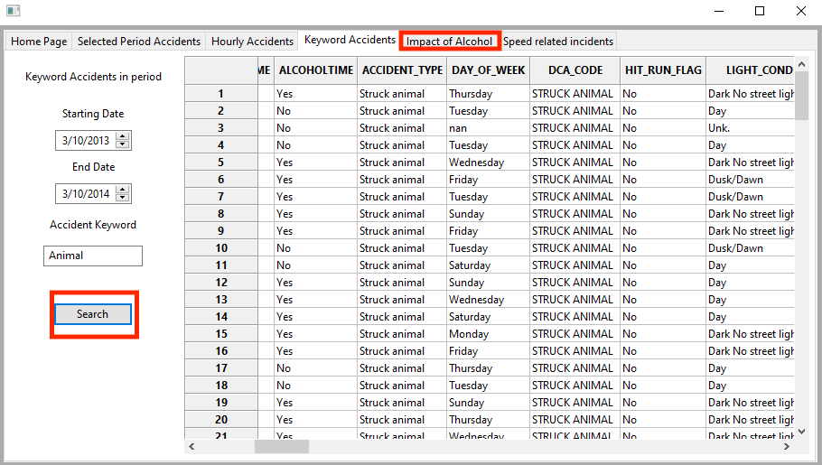

Impact of Alcohol
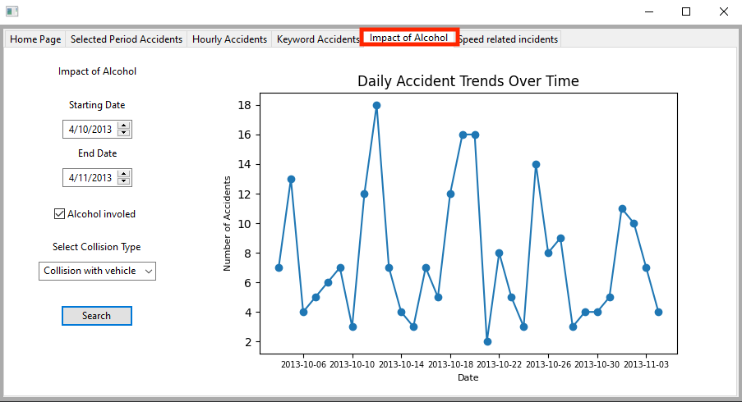

- First enter the start date
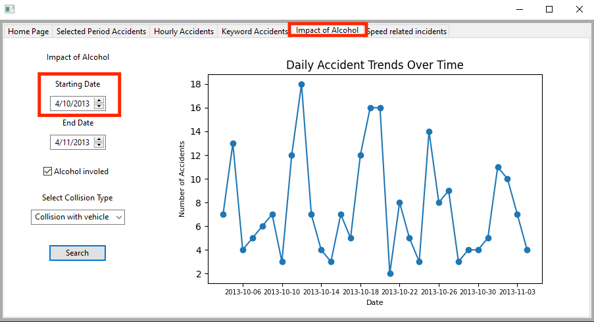

- Next enter the end date
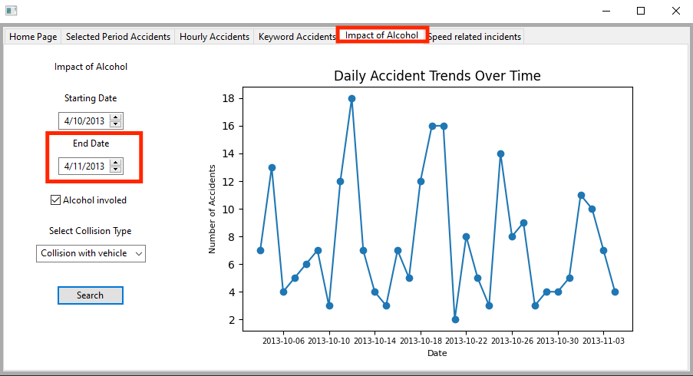

- Now you have the option to select if you want to see if alcohol was involved with the acceded by checking the box or not
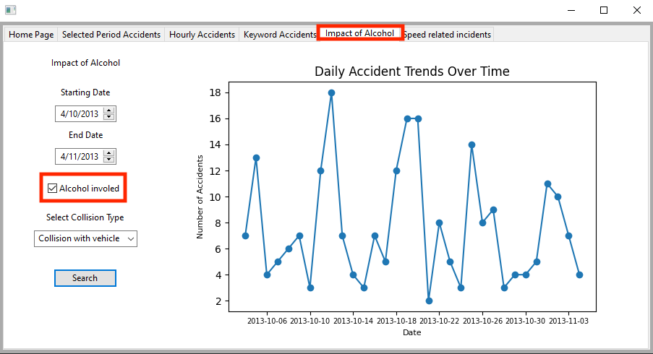
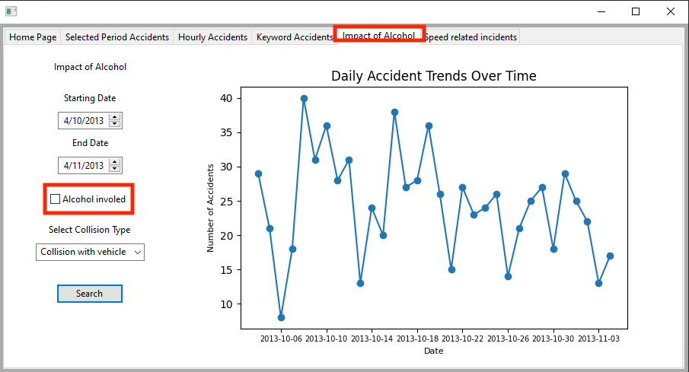

- Now click the search button and you graph will display on the right for your selected period
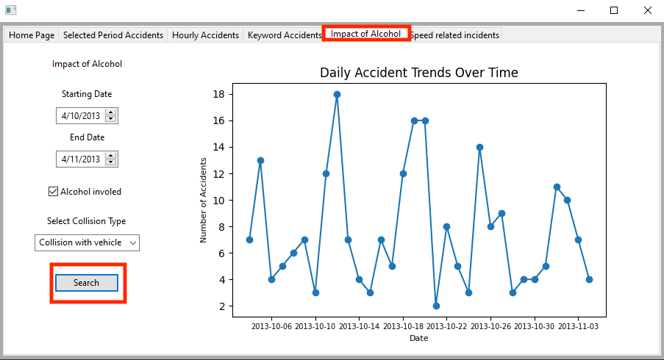

- Now to switch pages click the “Speed related incidents” tab in the task bar at the top
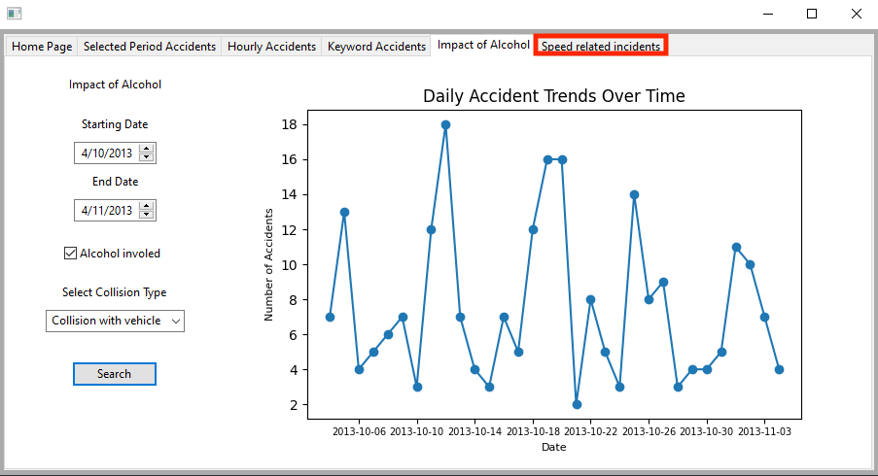

Speed Related Incidents

First when you open the page you will think its empty like the image below
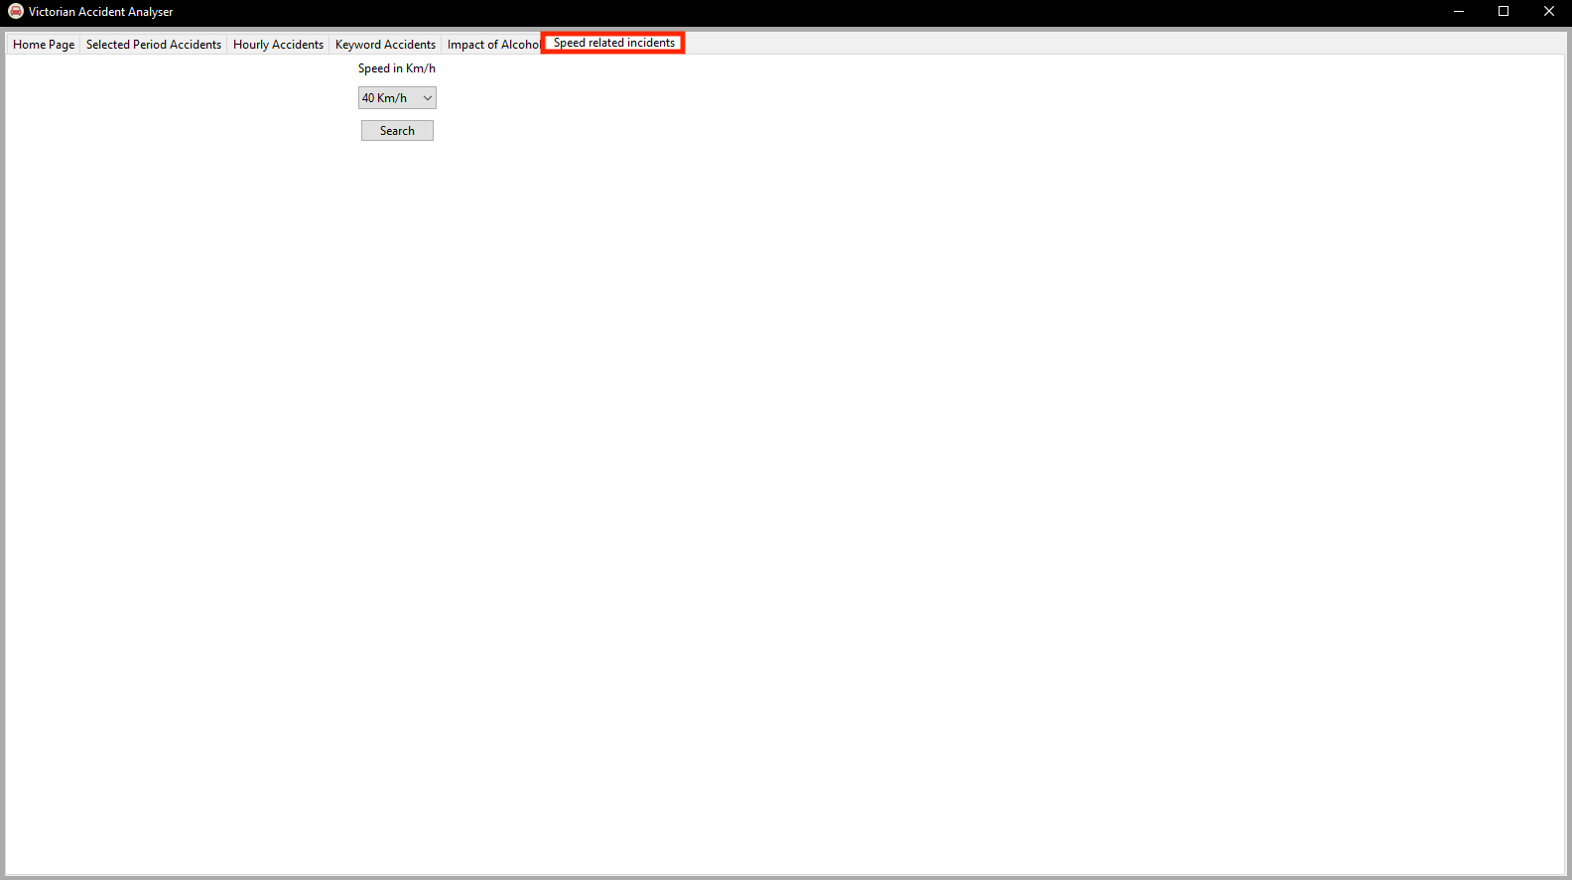

- First enter the speed you are looking for in the drop down menu

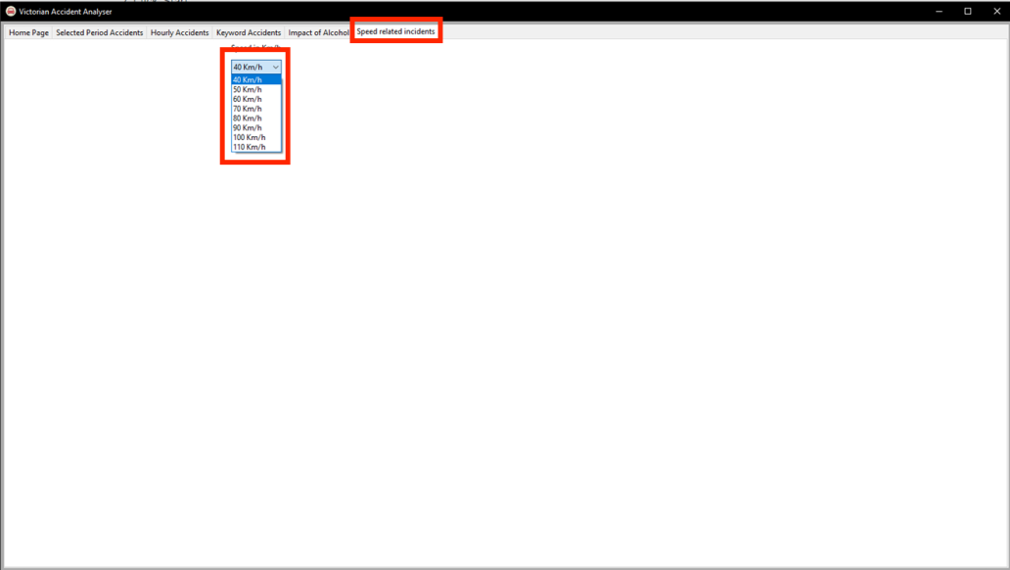

- Now click the Search button and watch your results come up. The graph below the search button is the total speed related accidents per day of the week and the graph to the right is the total injuries by severity

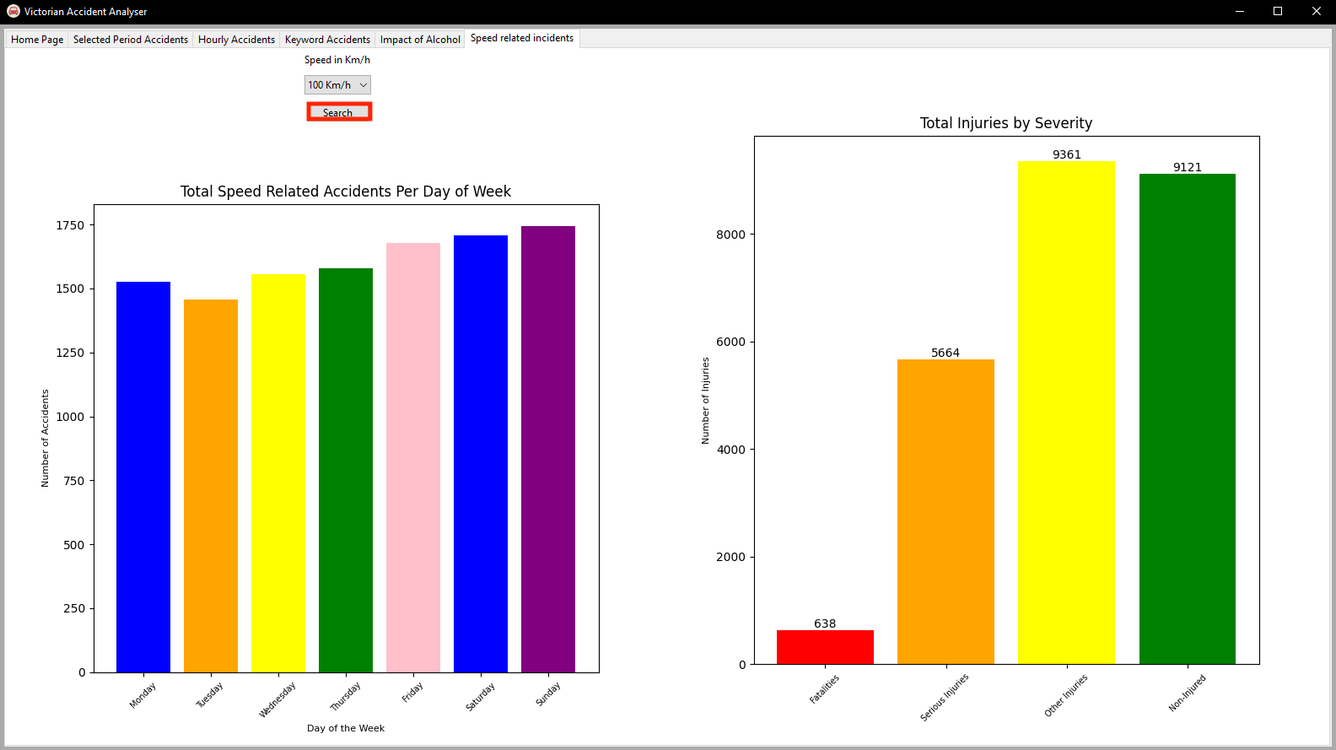

Trouble Shooting

If you encounter any installing issues like below:
- CMake Error at /opt/homebrew/Cellar/cmake/3.27.4/share/cmake/Modules/BundleUtilities.cmake:908 (message):
Command failed:
'/Users/pr35to/anaconda3/bin/install_name_tool' '-change' '/opt/homebrew/Cellar/wxwidgets/3.2.2.1_1/lib/libwx_baseu-3.2.0.2.1.dylib' '@executable_path/../Frameworks/libwx_baseu-3.2.0.2.1.dylib' '-change' '/opt/homebrew/opt/pcre2/lib/libpcre2-32.0.dylib' '@executable_path/../Frameworks/libpcre2-32.0.dylib' '-id' '@executable_path/../Frameworks/libwx_baseu_xml-3.2.0.2.1.dylib' '/Users/pr35to/wxFormBuilder/_install/wxFormBuilder.app/Contents/Frameworks/libwx_baseu_xml-3.2.0.2.1.dylib'
Call Stack (most recent call first):
/opt/homebrew/Cellar/cmake/3.27.4/share/cmake/Modules/BundleUtilities.cmake:983 (fixup_bundle_item)
_build/cmake_install.cmake:74 (fixup_bundle)
- CMake Error at _build/plugins/cmake_install.cmake:41 (file):
file INSTALL cannot find "/Users/pr35to/Desktop/ /Yr 2/Software
Technologies/Workshops/pythonProject3/wxFormBuilder/_build/stage/wxFormBuilder.app/Contents/PlugIns/libadditional.dylib":
No such file or directory.
Call Stack (most recent call first):
_build/cmake_install.cmake:47 (include)

I recommend:
- check to make sure you have everything installed correctly
- uninstall the environment and reinstall it
- create a new anaconda environment and repeat the same steps as explained above
- use Github environment discussion forum to get some help

FAQ

- Q1: “How do I download the wxformbuilder app”
- A1: “to download the wxformbuilder app for mac use the terminal app or terminal in pycharm and copy and paste the code from this link in either one of the terminal enivronments https://github.com/wxFormBuilder/wxFormBuilder. On a PC use https://github.com/wxFormBuilder/wxFormBuilder/releases and download the “wxFormBuilder-3.10.1-x64.exe” file”
- Q2: “why won’t the app run? ”
- A2: “Make sure you have successfully installed the system. You need to make sure you install the code to build the app and then install wxpython, matplotlib and pandas by typing into terminal “pip install wxpython”, “pip install matplotlib”, “pip install pandas”. “
- Q3: “how do I switch between pages?”
- A3: “in the task bar at the top of the page (in the photo below) scroll to the top and click between the pages.”

Contact us

To contact us please email us at:

liam.preston@griffithuni.edu.au
ben.white@griffithuni.edu.au
thomas.chapman2@griffithuni.edu.au

